Ministry of Education of the Republic of Moldova

Technical University of Moldova

Department of Software Engineering and Automatic

**REPORT**

*CDE*

Laboratory work no. 4

Performed by:

st. gr. FAF-161 Terman Emil

Verified by:

Prof. dr. hab. O. Lupan

(16.11.2017)

Chişinău - 2017

**The purpose of the work:**

We study the process of rectification in the scheme of electronic single-phase rectification with semiconductor diodes. We observe the influence of the filters on the form and value of rectified voltage.

**General theory:**

The criteria of classification of the rectifiers are the following. In the function of number of the phase of the transformer are defined single-phase and polyphase rectifiers. Single-phase rectifiers are divided in two categories:

* rectifiers which rectify the single winding, called half-wave rectifier.
* rectifiers which rectify both windings, called full-wave rectifiers.

Full-wave rectifiers are divided into:

* rectifiers with median point in the secondary of the transformer of the mains.
* point-contact rectifier

Considering the type of the used rectified elements we can distinguish uncontrollable (with semiconductor diodes) and controllable (with tiristor) rectifiers.

The electrical schemes of single-phase uncontrollable rectifiers are shown in figure 3.1.

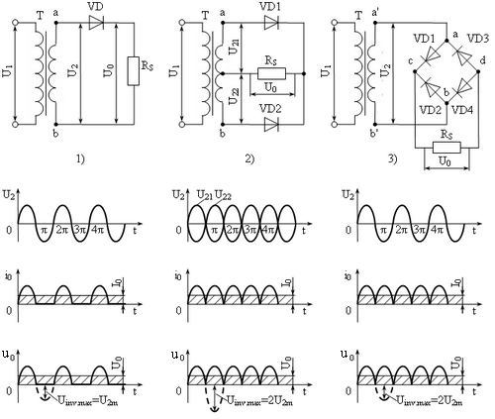

**Fig. 3.1:** The electrical schemes of rectifiers with semiconductor diodes and the time diagram of the currents and voltages.

1. single-phase half-wave rectifier
2. single-phase full-wave rectifier with median point in the secondary of the transformer
3. single-phase full-wave point-contact rectifier (bridge)

**The scheme**



Fig. 3.2. Base schemes of the smoothing filters

a) C-filter; c) LC-filter of “ Ί” form; e) RC-filter of “ Ί” form;

b) L-filter; d) LC-filter of “Π” form; f) RC-filter of “Π” form.

**Oscilograms**

Half wave rectifier:

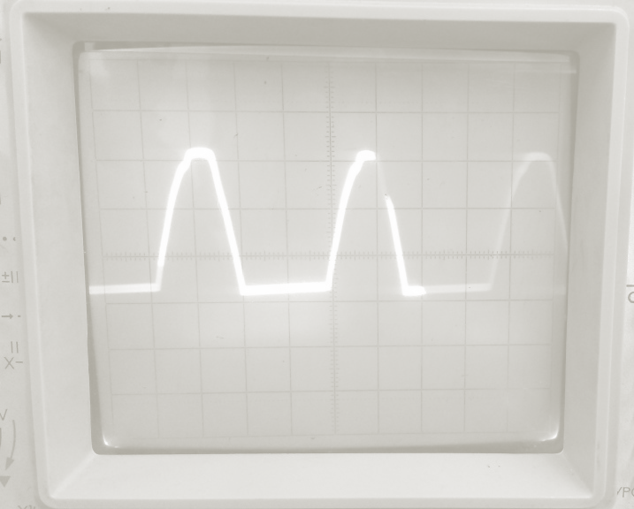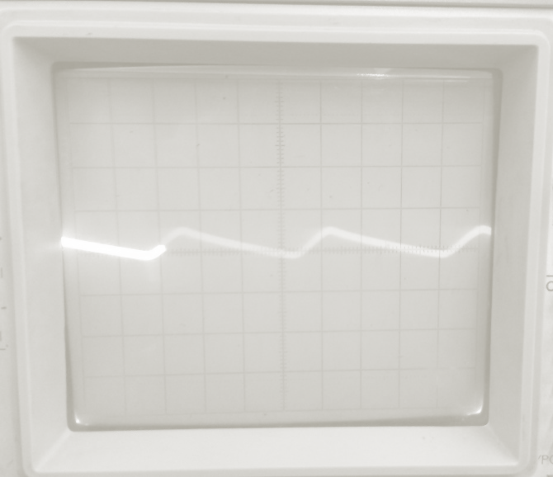

1. without filter
2. with filter C

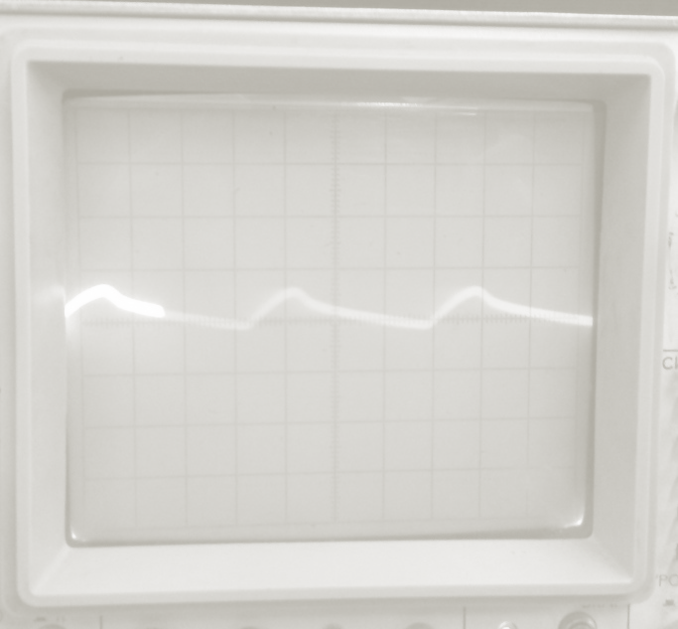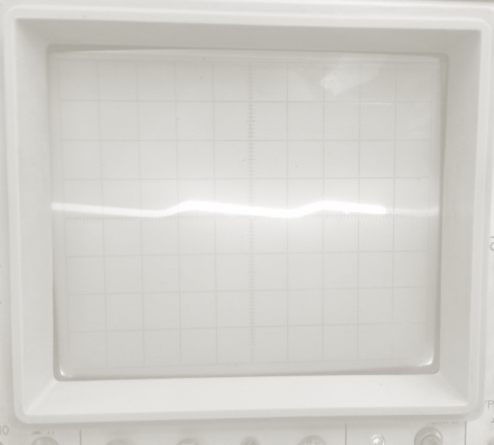

1. with RC filter
2. with CRC filter

Full wave rectifier:

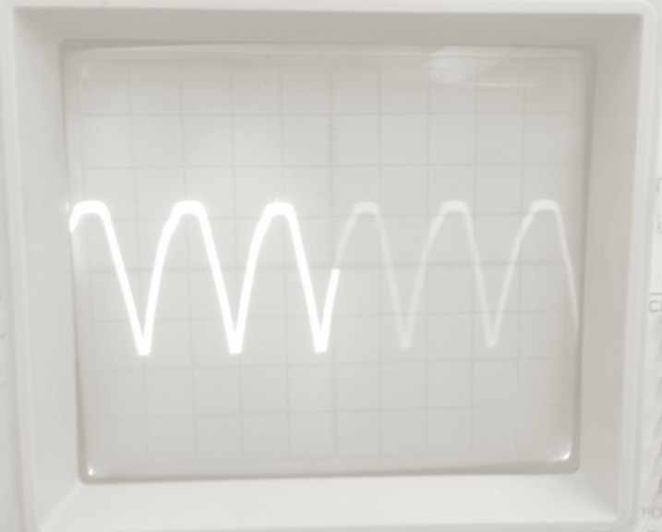 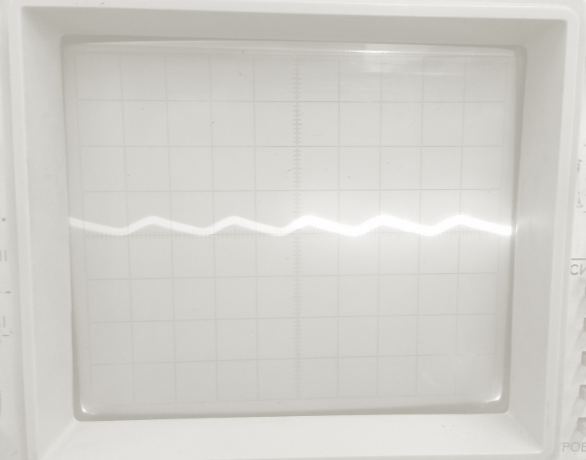

1. without filter
2. with filter C

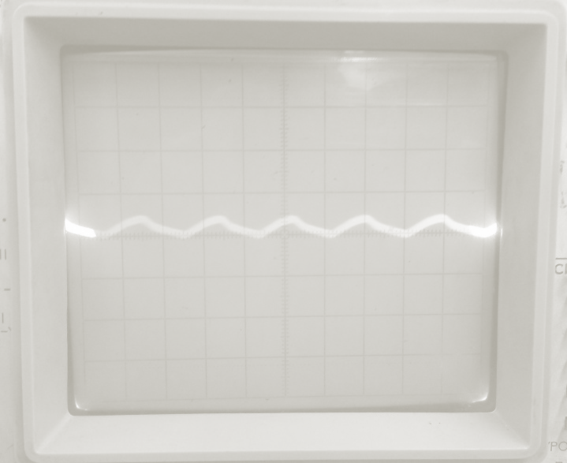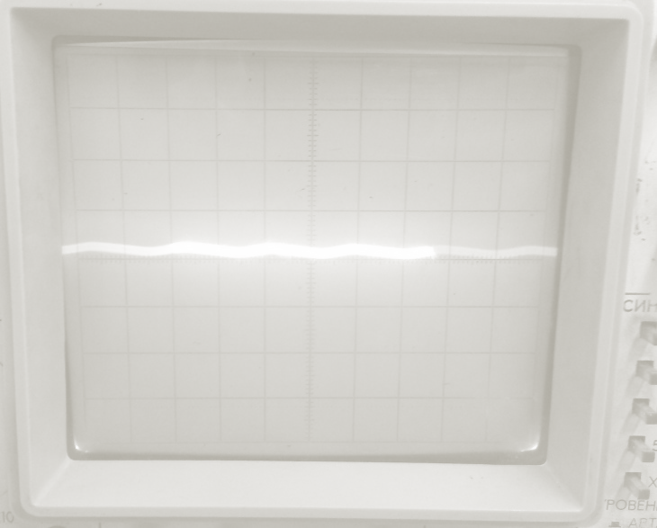

1. with filter RC
2. with filter CRC

Bridge rectifier:

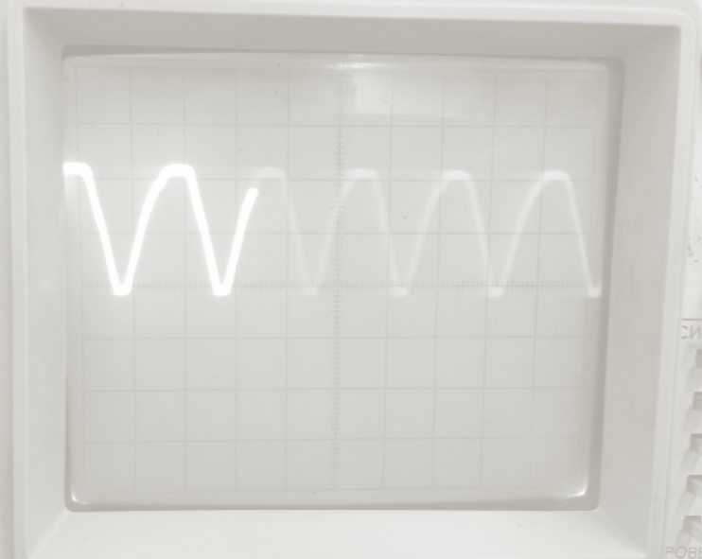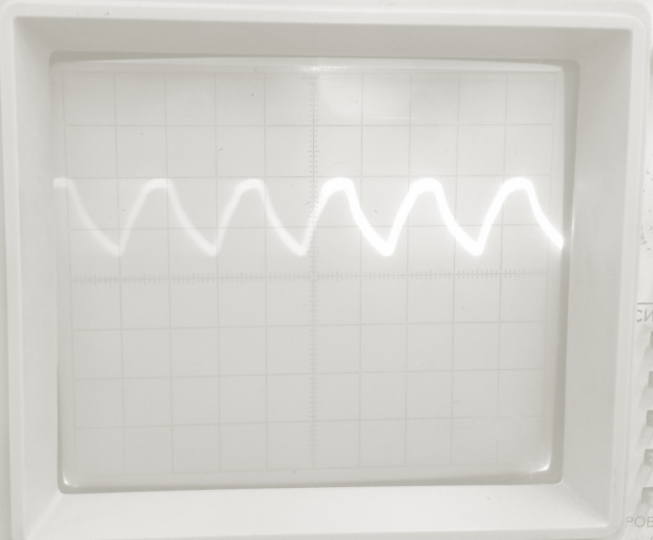

Without and with filter C

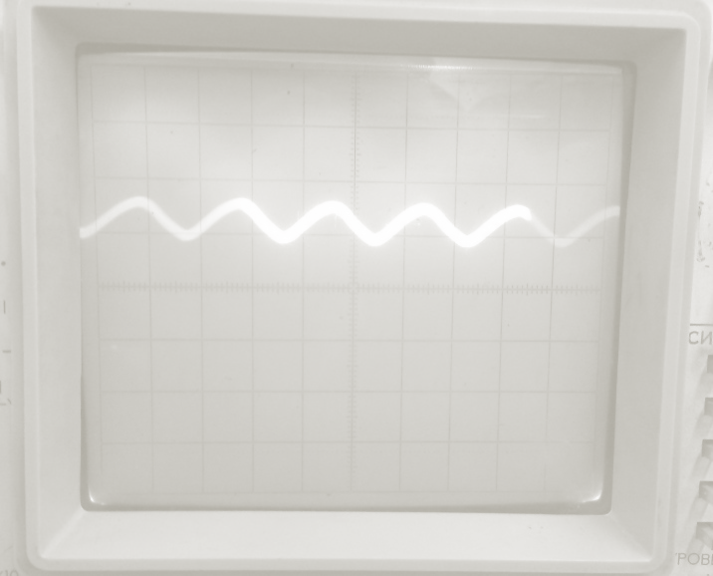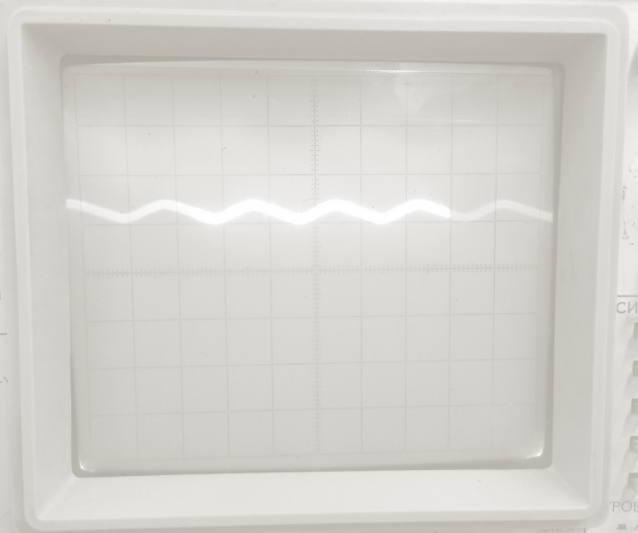

with filter RC with filter CRC

**Dataset for half-wave rectifier:**

|  |  |  |  |  |  |  |  |  |  |  |  |  |
| --- | --- | --- | --- | --- | --- | --- | --- | --- | --- | --- | --- | --- |
| *I, mA* | *5* | *10* | *15* | *20* | *30* | *40* | *50* | *60* | *70* | *80* | *90* | *100* |
| *Without filter* | 2,99 | 2,87 | 2,76 | 2,69 | 2,52 | 2,38 | 2,21 | 2, | 2,17 | 1,70 | 1,59 | 1,45 |
| *With filter C* | - | - | 0,15 | 0,2 | 0,3 | 0,4 | 0,5 | 0,57 | 0,65 | 0,71 | 0,8 | 0,82 |
| *With filter RC* | - | - | 0,18 | 0,24 | 0,25 | 0,45 | 0,51 | 0,56 | 0,60 | 0,60 | 0,58 | 0,5 |
| *With filter CRC* | - | - | 0,06 | 0,08 | 0,12 | 0,16 | 0,20 | 0,23 | 0,26 | 0,29 | 0,3 | 0,3 |

**Dataset for full-wave rectifier**

|  |  |  |  |  |  |  |  |  |  |  |  |
| --- | --- | --- | --- | --- | --- | --- | --- | --- | --- | --- | --- |
| *I, mA* | *10* | *15* | *20* | *30* | *40* | *50* | *60* | *70* | *80* | *90* | *100* |
| *Without filter* | 2,37 | 2,34 | 2,31 | 2,29 | 2,17 | 2,10 | 2,10 | 1,96 | 1,89 | 1,82 | 1,76 |
| *With filter C* | - | 0,08 | 0,11 | 0,15 | 0,2 | 0,21 | 0,27 | 0,31 | 0,34 | 0,37 | 0,4 |
| *With filter RC* | - | 0,08 | 0,1 | 0,14 | 0,18 | 0,22 | 0,25 | 0,27 | 0,29 | 0,30 | 0,32 |
| *With filter CRC* | - | 0,02 | 0,02 | 0,04 | 0,05 | 0,06 | 0,07 | 0,08 | 0,09 | 0,1 | 0,11 |

The voltage across the load falls twice faster in case of a half-wave rectifier than in case of a full-wave rectifier

**Dataset for bridge rectifier:**

|  |  |  |  |  |  |  |  |  |  |  |
| --- | --- | --- | --- | --- | --- | --- | --- | --- | --- | --- |
| *I, mA* | *15* | *20* | *30* | *40* | *50* | *60* | *70* | *80* | *90* | *100* |
| *Without filter* | 2,34 | 2, | 2,32 | 2,31 | 2,29 | 2,27 | 2,25 | 2,22 | 2,22 | 2,20 |
| *With filter C* | 0,12 | 0,17 | 0,25 | 0,32 | 0,38 | 0,43 | 0,5 | 0,55 | 0,60 | 0,65 |
| *With filter RC* | 0,12 | 0,16 | 0,22 | 0,29 | 0,35 | 0,39 | 0,43 | 0,47 | 0,5 | 0,53 |
| *With filter CRC* | 0,02 | 0,03 | 0,04 | 0,06 | 0,07 | 0,09 | 0,1 | 0,11 | 0,12 | 0,13 |

|  |  |  |  |  |  |  |  |  |  |  |
| --- | --- | --- | --- | --- | --- | --- | --- | --- | --- | --- |
| *I, mA* | *5* | *20* | *30* | *40* | *50* | *60* | *70* | *80* | *90* | *100* |
| *Without filter* | 2,34 | 2, | 2,32 | 2,31 | 2,29 | 2,27 | 2,25 | 2,22 | 2,22 | 2,20 |
| *With filter C* | 0,12 | 0,17 | 0,25 | 0,32 | 0,38 | 0,43 | 0,5 | 0,55 | 0,60 | 0,65 |
| *With filter RC* | 0,12 | 0,16 | 0,22 | 0,29 | 0,35 | 0,39 | 0,43 | 0,47 | 0,5 | 0,53 |
| *With filter CRC* | 0,02 | 0,03 | 0,04 | 0,06 | 0,07 | 0,09 | 0,1 | 0,11 | 0,12 | 0,13 |

|  |  |  |  |  |  |  |  |  |  |  |  |  |
| --- | --- | --- | --- | --- | --- | --- | --- | --- | --- | --- | --- | --- |
| **I0, mA** | **5** | **10** | **15** | **20** | **30** | **40** | **50** | **60** | **70** | **80** | **90** | **100** |
| **Fara filtru** | 2.11 | 2.08 | 2.06 | 2.03 | 2.01 | 1.97 | 1.95 | 1.91 | 1.87 | 1.85 | 1.83 | 1.81 |
| **Cu filtru C** | 0.38 | 0.45 | 0.51 | 0.67 | 0.73 | 0.81 |  |  |  |  |  | 1.00 |
| **Cu filtru L** |  |  |  |  |  |  |  |  |  |  |  |  |
| **Cu firltru LC (1)** |  |  |  |  |  |  |  |  |  |  |  |  |
| **Cu filtru LC (2)** |  |  |  |  |  |  |  |  |  |  |  |  |
| **Cu filtru RC (1)** | 0.27 | 0.31 | 0.36 | 0.38 | 0.38 | 0.39 |  |  |  |  |  |  |
| **Cu filtru RC (2)** | 0.15 | 0.17 | 0.18 | 0.18 |  |  |  |  |  |  |  |  |

The voltage across a bridge rectifier remains mostly constant for different values of the current;

**Conclusion:**

-In this laboratory work, we observed how for different filters the circuit acts differently.

-For all cases where L was also active, we had no voltage, therefore, we have only valid outputs for other filters.

From the results of this laboratory work, there could be drawn several conclusions:

* + - 1. **The voltage across a bridge rectifier remains mostly constant for different values of the current; (last diagram)**
      2. **The voltage across the load falls twice faster in case of a half-wave rectifier than in case of a full-wave rectifier; (second diagram)**
      3. Even if a bridge and a full-wave rectifier act mostly the same, the slope of the voltage with respect to the current is smaller in case of the bridge rectifier than in case of the full-wave one;